GSM/GPRS/GPS TRACKER
MANUAL

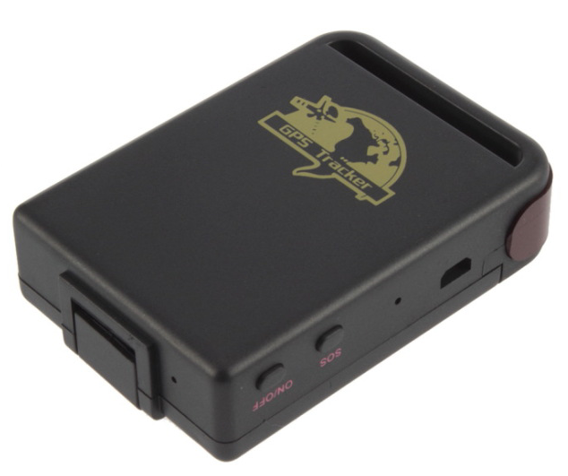

UPreface

Thank you for purchasing the tracker. This manual shows how to operate the device smoothly and correctly. Make sure to read this manual carefully before using this product. Please note that specification and information are subject to changes without prior notice in this manual. Any change will be integrated in the latest release. The manufacturer assumes no responsibility for any errors or omissions in this document.
Contents
◆Quick using 3
◆Attention 3
1. Summary 4
2. Application 4
3 Hardware Description 4
4 Specs. 5
5 Usage 6
5.1 SIM card 6
5.2 Battery and Charger 6
5.3. Startup 6
6 Device Parameter Settings 7
6.1 Initialization 7
6.2 Set password 7
6.3 Authorization 7
6.4 Single Tracking 8
6.5 Get geographical location 8
6.6 Auto continuous track 9
6.7 Voice Surveillance 9
6.8 Storage 9
6.9 Geo-fence 10
6.10 Overspeed alarm 10
6.11 SOS alarm 11
6.12 Time Zone Setting 11
6.13 GPRS setting 11
6.14 IP and Port setting 12
6.15 Check device setting parameters 12
6.16 Web platform GPS tracking software 12
7 Cautions 12
8 Faults & The solutions 13

◆Quick using
1）Proper insert GSM card and install battery.
2）Press turn on button for 4 seconds, flash at 2 seconds,put device outside.
3）Around 50seconds, dialing device number, it will hang up and reply tracking message with valid Long and lat stands for device can work normall.
4）If need track online system, send 2 SMS connects to platform as below:
SMS 1: #IP#123456#58.64.200.27#8169#
SMS2: #apn#123456#APN of operator#APN user name#APN password#
5）Login platform to track in real time(please contact supplier).

◆Attention
◆Device failed located
1）Failed located: message replied with all 0, make sure device started outside not in room.
2）Can’t reach the call: make sure SIM card has balance and installed properly.
◆Device can’t track on platform
1）Make sure device can work and reply valid tracking long&Lat in SMS.
2）Send SMS“TCP”check GPRS setting：IP,port,APN are corret，Show A（A means GPS located，V means not located）.

1. Summary
Working Based on existing GSM/GPRS network and GPS satellites, this product can locate and monitor any remote targets by SMS or internet.

2. Application
- Vehicle rental / Fleet management etc
- Powerful magnet+ water proof, adsorbing in the hidden place of car for tracking secretly.
- Protect child / the old / the disabled / pet etc
- Provide peace-of-mind for businessmen
- Personnel Management
- Criminals Tracking

3 Hardware Description
3.1 Front face 3.2 Rear face
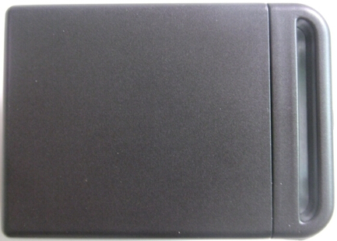
3.3 Side face
Indicator for signals.
update software, charge battery from here.
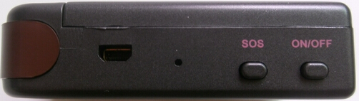
SOS Button
ON /OFF Button
3.4 Bottom face
Built-in GSM/GPS antennas is inside
Microphone
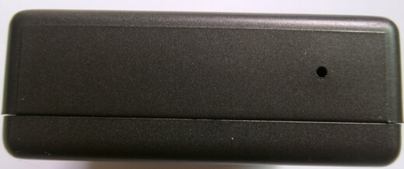
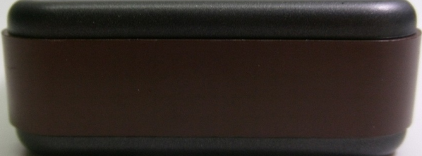

3.5 Interior
GSM Card Slot
Install the battery like this

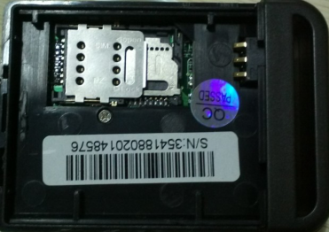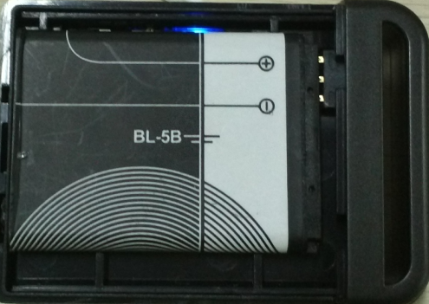

4 Specs.
Content | Specs.
Dim. | 64mm x 46mm x 17mm
Weight | 50g
Network | GSM/GPRS
Band | 850/900/1800/1900Mhz
GPS chip | UBLOX chip
GPS sensitivity | -159dBm
GPS accuracy | 5m
Time To First Fix | Cold status 45s  Warm status 35s  Hot status 1s
Car charger | 12—24V input  5V output
Wall charger  Battery charger | 110－220V input  5V output
Battery | Chargeable changeable 3.7V 850mAh Li-ion battery
Standby | 12 hours
Storage Temp. | -40°C to +85°C
Operation Temp. | -20°C to +55°C
Humidity | 5%--95% non-condensing

5 Usage

5.1 SIM card
Make sure that there is no call transfer and call display is on, and PIN code off. The SMS message must in Text format, can’t be identified for PDU format.

5.2 Battery and Charger
Do charge the battery to capacity in 8 -12 hours for first time. Please use the battery and charger provided by the manufacturer. This unit adopts built-in Li-ion battery, and full battery can standby 12 hours. After first use, the battery usually should be charged fully in 10 hours.
Cautions:
a: For Li-ion battery, which contains harmful chemicals and may burst, please don’t bump, puncture it violently and keep it off fire.
b: Please charge the battery in time to keep it working normally.

5.3. Startup
- Put the SIM card and battery in place.
- Turn on the unit outdoor by pressing the “on/off” button for 4-5seconds until the indicator is flashing.
- After 45 seconds, the unit will begin to work and acquire the GSM signals as well as the GPS signals. The indicator will keep flashing every 3 seconds when the unit has received the signals.
- For first use, please initialize the unit and restore it to default setting.
- When this unit receives GPS signals normally, you can use it and do any setting as the instructions of this manual.

Device Parameter Settings
6.1 Initialization
Send SMS “#begin#123456#” to the tracker, it will reply “begin ok” and initialize all the settings. (Default password: 123456).
Remark: initialization is resetting all the parameters to factory defaults.
For example, send SMS “#begin#123456”, If succeeded, it will reply“begin ok”.

6.2 Set password
6.2.1Set Password: Send SMS: “#password#old password#new password#” to the unit to change the password.
For Example, send SMS: “#password#123456#666888#” to device, it will reply SMS: “password OK”.
6.2.2 Make sure the new password is in 6 digits arabic numbers, or the device cannot recognize the password.
6.2.3 Resume original password: send SMS: “#resume#” to the device, it will reply SMS: “resume password ok, password is 123456”.

6.3 Authorization
6.3.1 Set authorization: send SMS “#admin#password#cell phone number#” to set up authorized number, device will reply “admin ok”.
6.3.3 Delete authorization send SMS“#noadmin#password#authorized number#”to delete the authorized number, device will reply “no admin ok”.

6.4 Single Tracking
6.4.1 If there is no authorized number, any number dials up the device number, it will report tracking message; if already set authorized number, then it will not respond when an unauthorized number calls it.
6.4.2 Dialing tracking: make a call to device number, it will hang up and reply a real-time tracking message as below.
6.4.3 SMS tracking: send SMS“#smslink#123456#”, it will reply a real-time tracking message as below.
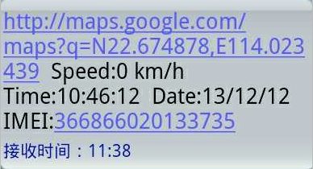
*Tracking location, when GPS signals is weak, you will receive the last location when GPS is available. If it is different with its exact current location, pay attention to check the time included in the SMS.

6.5 Get geographical location
6.5.1 Must set the SIM Card APN parameter firstly before using this function, if there is APN user name and password, Please refer to point 6.13 to set.
6.5.2 Send SMS: “DW” to device, it will reply current location info：around 118m, jianhui rd, bao’an district, Shenzhen, China.
Note: this function may not work in some certain area and need connect to platform can work.

6.6 Auto continuous track
6.6.1 Unlimited time auto track: Send SMS “#at#30#sum#0#” to the device. Remark: device must be connected to tracking software.
6.6.2 Cancellation: Send SMS “#noat#password#” to the device.

6.7 Voice Surveillance
6.7.1 The command to switch between Track and Monitor are “tracker” and “monitor
6.7.2. The default mode is “track” (Tracking status).
6.7.3. Send SMS “#monitor#password#” to the device, and it will reply “monitor ok!” and switch to “monitor” mode. Then use mobile phone to dial the device number, it will get though and enter voice listening function.
6.7.4. Send SMS “#tracker#password#” to the device, it will reply “tracker ok!” and restore to “track” mode.

6.8 Storage
6.8.1 Auto Storage：When the tracker devices lost GSM signals or fall offline from GPRS, tracker will store the tracking position automatically in the flash, when GSM signals get back, all the storage data will be sent to monitoring platform (server).
6.8.2 Storage Volume: Built-in flash 1MB (store about 7,000 positioning data); external TF card support 16 GB at most.
6.8.3The stored data will be sent to the tracking system HTUwww.gps228.comUTH through the GSM signal recover.

6.9 Geo-fence
Set up geo-fence for the unit to restrict its movement within a district. The device will send message to the authorized number automatically when it exceed the district.
6.9.1 Set up
When the unit stays immobile in a place, send SMS: “#stockade#password#semidiameter#” to unit to set the restricted district. In case of breach, it will send SMS “stockade! + Geo-info” to the authorized number.
For example, Send SMS: “#stockade#123456#3#”, “3” represents 300 meters.
6.9.2 Cancel: Send SMS: “#nostockade#password#” to deactivate this function, it will reply “no stockade ok”.

6.10 Overspeed alarm
6.10.1 Set up: Send SMS:“#speed#password#speed number in 3 digits#” to the device (suppose the speed is 80km/h), Eg, send SMS “#speed#123456#080#”, and it will reply “speed ok ”. When the car moves exceeding 80 km/h, the unit will send SMS alert “speed alarm” to the authorized number.
6.10.2 Cancel: send SMS“#nospeed#password#” to deactivate the overspeed alarm. it will reply “cancel speed ok”.

6.11 SOS alarm
Press the SOS for 3 seconds, it will send “SOS alarm + Geo-info” to the authorized number.

6.12 Time Zone Setting
Remark: UTC+8 is default time zone.
6.12.1 Send SMS “#timezone#password#direction#time zone value in hours#time zone in munites#”. If set OK, it will reply “time zone ok”. For example, if in UTC-6, send SMS “#timezone#123456#W#6#00#”. If in UTC+5.30, send SMS “#timezone#123456#E#5#30#”.

6.13 GPRS setting
User must send SMS via cell phone to set IP, port and APN before starting GPRS.
6.13.1 Setting APN
6.13.1.1 APN standards for Access Point Name and differs from country to country. For more information about the local APN, inquiry from your local GPRS network operator.
6.13.1.2 Send SMS “#apn#password#APN content#APN user name#APN password#” via a cell phone and if succeeded, the tracker will return the message “set APN OK”.
E.g. send SMS command “#apn#123456#cmnet#”.
Notes: CMNET is the APN content of China Mobile (it has no APN user name and password). If there is no APN user name and password, then no need to write APN user name and password.

6.14 IP and Port setting
6.14.1 Send SMS “#IP#password#ip address#port number#”. If succeeded, “set ip address and port ok” will be returned by SMS.
E.g, Send SMS command “#IP#password#58.64.200.27#8169#” to the device (58.64.200.27 is IP, 8169 is port)

6.15 Check device setting parameters
Send SMS “TCP” to device, it device will reply SMS“ IP+port+APN+GPRS setting (A: valid, V: invalid).

6.16 Web platform GPS tracking software
Web based platform www.gps228.com, further details please contact manufacturer.

7 Cautions
Please comply with the instructions to extend the unit life:
7.1 Keep the unit dry. Any liquid, i.e. rain, moisture, may destroy or damage the inside circuitry.
7.2 Don’t use & store the unit in dusty places.
7.3 Don’t put the unit in overheated or overcooled places.
7.4 Handle carefully. Don’t vibrate or shake it violently.
7.5 Clear the unit with a piece of dry cloth. Don’t clean in chemicals, detergent.
7.6 Don’t paint the unit, this may cause some foreign materials left in between the parts.
7.7 Don’t disassemble or refit the unit.
7.8 Please use the battery and charger provided by manufacturer. Using other batteries and chargers will cause unwanted situation.

8 Faults & The solutions
Faults | Solution
Startup Fail | Check the battery and see if it is fully charged or correctly installed.
Hang up Fail | In existence of an authorized number, an unauthorized number dials up the unit. Please initialize the unit and re-set up the authorized number.
No GSM Signal | Please make sure SIM Card is GSM Net and installed correctly; also call display should be on; but no call transfer and PIN code off.

