GPS Vehicle Tracker
(GPS+GSM+SMS/GPRS)
User Manual

Preface
Thank you for purchasing the tracker. This manual shows how to operate the device smoothly and correctly. Make sure to read this manual carefully before using this product. Please note that specification and information are subject to changes without prior notice in this manual. Any change will be integrated in the latest release. The manufacturer assumes no responsibility for any errors or omissions in this document.

1. Product packing parts:
1.1 Mike 5P charging line (standard accessories)
1.21A charger (optional accessories)
1.3 user manual 1pc (standard accessories)
(accessories products refer to actual products)

- Product features：
2.1 GSM four frequency (GSM850 / 900 / 1800 / 1900MHz) system global general purpose;
2.2 built in switching power supply, charging voltage 5V DC;
2.3 GPS continuous GPS positioning, GPRS periodic reports;
2.4 support SMS check location information;
2.5 built in vibration sensors to achieve intelligent vehicle anti-theft;
2.6 waterproof design
2.7 built in battery, can be used circularly;
Content | Specs.
Box Dim. | 108mm x 58mm x 41mm
Weight | 188g
Network | GSM/GPRS
Band | 850/900/1800/1900Mhz
GPS chip | UBLOX
GPS sensitivity | -158dBm
GPS accuracy | 10m
Time To First Fix | Cold status 35-80s  Warm status 35s  Hot status 1s
Battery | Build-in 3.7V 6000mAh Li-ion battery
Storage Temp. | -40°C to +85°C
Operation Temp. | -20°C to +55°C
Humidity | 5%--95% non-condensing

3.the installation instructions
3.1 preparation before installation
3.1.1 open the package and check that the model of the equipment is correct and the fittings are complete, otherwise contact your dealer;
3.1.2 device terminal needs to plug in a GSM SIM card to work properly, GSM Unicom card or mobile optional (GSM network generic). Please prepare a valid SIM card.
Note:
(1) before installing or removing the SIM card, insert the card in the correct way first;
(2) terminal SIM card GPRS function;
(3) the terminal SIM card needs to open the call display function (depending on the customer's need to select the function not open or not);
(4) make sure that the terminal SIM card is used properly.
3.2 select installation location
Terminal installation is recommended for concealed installation, installation of terminals recommended by the installer, installation by professional bodies, and attention to the following:
3.2.1 in order to avoid rogue damage, device selection should be possible to hide;
3.2.2 avoid launching with the source, such as reversing radar, anti-theft and other vehicle communications equipment;
3.2.3 can be used to tie a band or a strong sponge with double adhesive tape;
3.2.4 devices are built with GSM antennas and GPRS antennas, and should be installed at the receiving end (Xiang Tiankong) and with no metal shield on the recommended mounting position:
The following the decorative frame inside the front windshield of residence;
The front panel (the skin is non metallic materials) in the sanctuary;
Decorative board the windshield under.
3.2.5 if the car and air work, paste the metal insulation layer and heating layer, will reduce the GPS receiver signal, resulting in abnormal GPS work, please change the device installation position.

4. Operation instruction:
Turn off vibration sensor | LEVEL,0# | Shock does not wake up
Turn on the vibration sensor | LEVEL,4# | Vibration wakeup
Set time positioning | TIMERLONG,T# | T=1~24hour
Off time positioning | TIMERLONG,0#
Real-time location | GPSON,ON# | Position for 5 minutes
Cancel dormancy | SENDS,0# | Always online
Resting at rest | SENDS,5# | Rest after 5 minutes of rest
GPRS shutdown | HALFMODE,ON# | Turn GPRS off after sleep
GPRS open | AT^HALFMODE,OFF# | Stay connected to GPRS after sleep

5. landing on the global positioning service platform
Users can log on to the dealer's global positioning service platform to view the location and status of the vehicle, and the corresponding operation, service platform website, please consult your dealer.

Platform operation:
- APP
Apple Android universal two-dimensional code

Apple System Mobile Search at APP Store: XUHANGJIA
Andrews system phone in the use of market search: XUHANGJIA

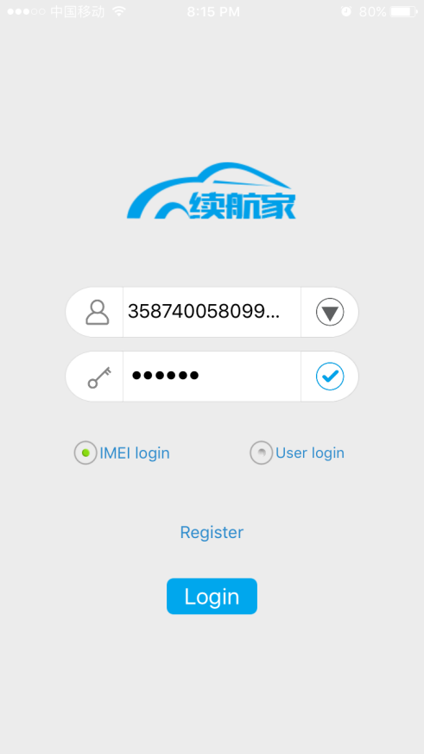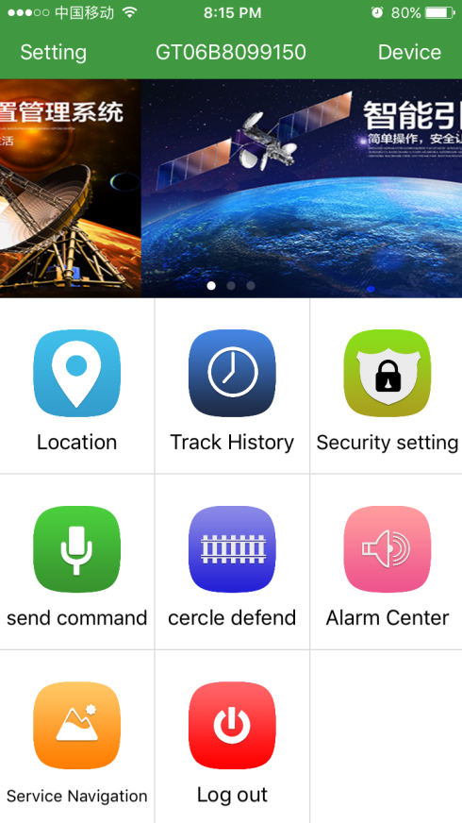

2. site platform:
1) open the web site gps889.com and select IMEI or user type. Enter the IMEI code of the device, and then enter the password (default 123456), as shown:

