LCD-850 USER MANUAL
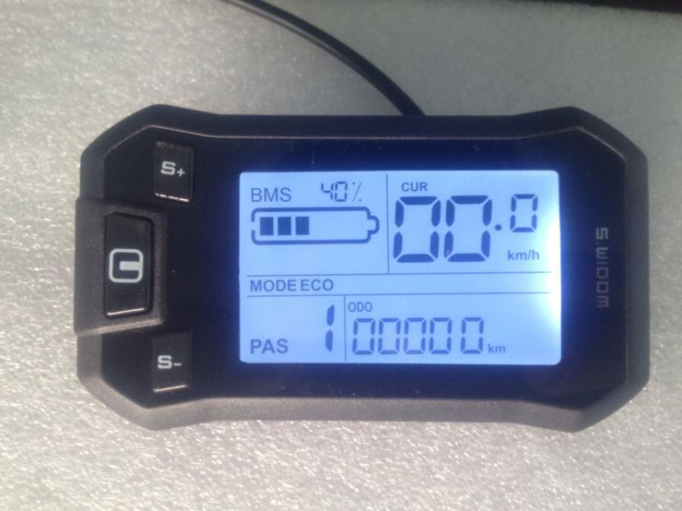

Model：850V
Work Voltage：DC24V 36V 48V

接线方式：
- 红线（D+）:电源正极输入
- 黑线（GND）：电源负极
- 蓝线（DS）：控制器电门锁
- 黄线（DD+）：灯光控制正极（如控制器软件硬件支持灯光控制该线可以不接）
- 绿线（RX）:通讯接收
- 白线（TX）：通讯发射
- 可扩展功能：PWM电压型助力档位控制 、独立外接速度传感器

Connection:

1. red line (D+): power positive input

2. black line (GND): power negative

3. blue lines (DS): controller switch lock switch

4. yellow line (DD+): light control positive (if software and hardware of the controller support light on/off, this line is unnecessary to be connected )

5. green line (RX): communication receiving

- white line (TX): communication emission

- Extensible function: PWM voltage type power shift control, independent external speed sensor

一、Function：
1、Display Function
Display function, speed display, power ratio display, electricity indication, erro prompt, Total mileage, Single mileage, Cruise speed control, Brake indicator, Headlight display
2. Control and Set Function
Power switch control, headlight switch control, 6Km/h driving control, real time cruise control and wheel diameter setting, 5 gear power setting, maximum speed setting, automatic sleep time setting, backlight brightness setting, start setting, driving mode setting, power sensitivity setting, disk type setting, voltage class setting, current limit value setting,
3. communication protocol: UART
All the contents of the display (within 1s full display )
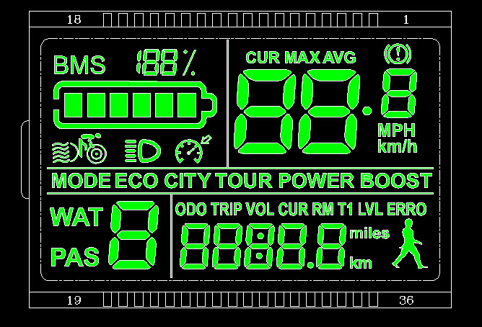
introduction:
1.headlight
2.the class of voltage stage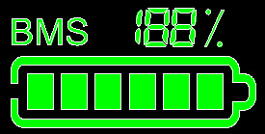
3.multi-function display area

总里程ODO(total odometer)、单次里程TRIP(single mileage)、数字电压VOLT(voltage)、数字电流CURRENT、剩余里程RM（remain mileage）、运行时间TIME、电机功率WAT(motor power)
4.Erro display
ERRO 1：电机故障motor erro
ERRO 2：转把故障 handlebar
ERRO 3：控制器故障controller
ERRO 4: power off brake handle
ERRO 5: undervoltage protection
ERRO 6: communication failure, the instrument can not get the controller output
ERRO 7: communication failure, the controller can not get the output of the meter
- Speed display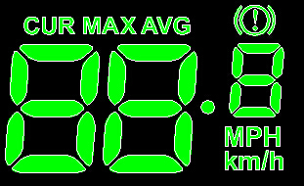
CUR:currrent speed；MAX:maximum speed,AVG :average speed
Unit: MPH, KM/H
4 ways for speed:
1. Connect Holzer signal of motor
2. The controller sends the motor Holzer signal data to the meter
3. The slow Holzer signal of wheels rotating in one circle
4. The slow Holzer signal of wheels rotating in one circle is transmitted to the meter by the controller,
(the time of a single Holzer cycle, unit: 1MS)
The instrument calculates the true speed according to the wheel diameter and signal data (the motor Holzer also needs to set the number of magnet steel)

- Boost state display
Boost state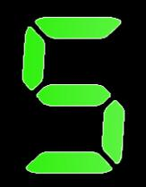（0-5 gear）
注：3gear boost state dispaly
EC:1 gear；TOUR:2 gear；BOOST:3 gear 5 gear；

ECO：1 gear；CITY:2gear；TOUR:3gear；POWER:4gear；BOOST:5gear.
6KM/h cruise:、real time cruise:

7.Setting:
P01: backlight brightness, level 1 is darkest, level 3 is brightest;

P02: mileage unit, 0:KM; 1:MILE;

P03: voltage level: 24V, 36V, 48V, default 36V;

P04: dormancy time: 0, not dormancy; other numbers are dormancy time, range: 1-60; unit minutes;

P05: power shift:
0, 3 gear mode: 1 gear 2V, 2 gear, 3V, 3 gear, 4V;

1,5 gear mode: 1 gear 2V, 2 gear, 2.5V, 3 gear, 3V, 4 gear, 3.5V, 5 gear, 4V;

P06: wheel diameter: unit, inch; accuracy: 0.1;

P07: speed measuring magnet number: range: 1-100;

P08: speed limit: range 0-50km/h, 50 means no speed limit,
1. non communication state (instrument control): when the speed is higher than the set speed, turn off the PWM output; when the speed is reduced to less than the set speed, automatically open the PWM output, driving speed for the current speed (+ 1km/h; only for the booster speed limit, handlebar no limit)

2. communication status (controller control): drive speed is maintained at set point,error: + 1km/h; (booster and handlebar speed limit)
Note: The value is based on kilometers, and when the unit is converted from kilometers to miles, the speed of the display interface is automatically converted to the correct mileage value,But the speed limit data set at this menu is not converted, which is inconsistent with the speed limit value of the actual display mile speed;
P09: zero start(normal start), non-zero start settings(push the vehicle to start), 0: normal start; 1: non-zero start(push the vehicle to start);

P10: drive mode settings 0: booster drive (through the booster shift to determine how much output, at this time handlebar is invalid).
1: electric drive (through the turn drive, at this time the gear stalls invalid).
2: booster drive and electric drive coexist at the same time (electric drive is invalid in the zero start state).

P11: booster sensitivity setting range: 1-24;

P12: booster setting range: 0-5;

P13: booster magnetic disk type 5, 8, 12 magnetic steel three types of magnetic disk type

P14: controller current limit setting default 12A range: 1-20A

P15: handlebar speed duty setting range: 0-100

二、Button introduction：
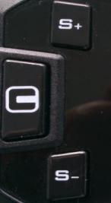
Button operation: short press and long press, and combination button long press.

Short press for quick / frequent operations: such as
1. 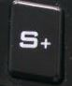 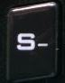riding，change booster/speed shift， short press one time
2. riding, switch multi function display data,short press
Long press: to switch different mode on/ off
Long press combination button: parameter setting
Specific operation explanation：
- Modify the boost ratio / electric gear position

Suppose the current is the boost mode
  - short press ， booster + 1
  - short press， booster- 1
- Switch speed display
Long press,+switch the way of speed display

- Set / cancel 6Km/h cruise, real-time cruise, switch headlights

Vehicle is in static state,long press，will enter the 6KM/h cruise mode; the vehicle in pure electric riding state，long press，enter the real time cruise mode, if the current state is cruise mode, then will be cancelled;
Long pressheadlight on/off
- LCD display on/off
If current screen is working，long press，the LCD display will turn off, otherwise the screen will open
- Switch multi function display
short press can switch the value of the multi function display area
- Parameter setting
Long press+ you can enter the parameter setting interface, and the parameters you can set include:wheel diameter (inch: inch), magnet number, liquid crystal brightness, undervoltage point, etc. (see more details in behind);
Short press，oradd and subtract to the settings, the parameters will flash after being changed, select the setting value after,
- a. long presssave the current value and stop the parameter flicker;
b.short pressswitch to the next parameter, and save the setting value of the previous parameter;
2. press+，quit setting and save parameters, if not press, after 10 seconds will automatically exit and save the modified parameters.

七、ODO zero cleared
In the parameter setting interface, the short press to the ODO settings interface, short press, at this time the total mileage is flashing, long press 5-6 seconds, total mileage is cleared.

Note: due to the upgrade of the company's products, the contents of the products you may get will be different from the instructions, but it will not affect your normal use.

Diagram:

