MLS061 Installation Manual
客户名称 |  |  | 仪表名称 |  | MLS061 | 页数 | 3页
序号 | 项目 |  | 功能/参数
 | Operating Voltage |  | 9～18VDC 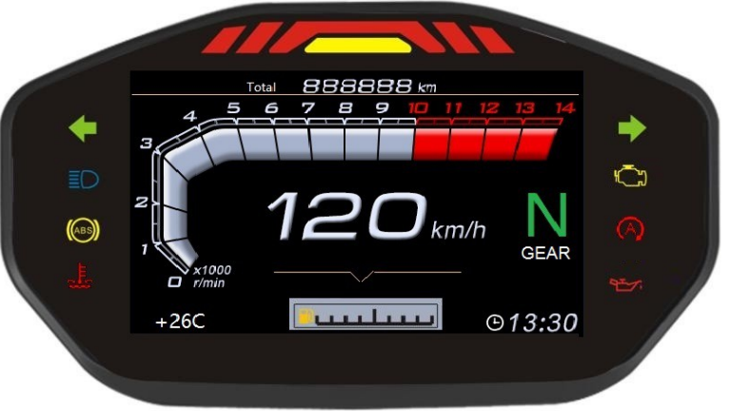
 | Speedometer |  | 1. Calculate the vehicle speed according to the received pulse signal  2. Metric and British  3. No pulse signal, displayed as 0  4. The number of backstage magnets and tire circumference can be set  5. Display speed increase 5%  6. When there is a speed, 1, 2, and 3 lights are displayed on the horse (Light 1 is 3 LEDs in parallel)
 | Enigne speed signal |  | Liquid crystal display, 166Hz to 10 × 1000r / min.  Number of cylinders can be set in the background  Set to 2: 166.6Hz for 10 × 1000RPM  Set to 4: 333.3Hz corresponds to 10 × 1000RPM  Over-rotation headlights: the speed is 9-10 × 1000RPM, the yellow light is always on  Over-rotation light: The yellow light turns off when the speed reaches 10 × 1000RPM or more, and the red light blinks at 2Hz.
 | Fuel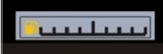 |  | Liquid crystal display, with fuel sensor connected, fuel block display, no connection without display  - When judging whether there is a sensor, there is no sensor, and the fuel related is not displayed. If there is a sensor, it is displayed according to the corresponding resistance range.  Judge the presence or absence of a sensor, a value is being judged, not just power on, it will judge  3.No driving damping, the entire segment is 10 seconds, driving damping, 7 seconds per division  4.The fuel level is as low as 1 block and below, the front oiler flashes  5.Set 2-wire or 3-wire sensors in the background  Piece 0 block, E, F, tanker symbol flashes 1 flash, oil pot flash 1Piece 2Piece 3Piece 4Piece 5Piece  2 lines 90Ωabove 89－81 80－71 70－53 52－34 33－15 14Ωbelow  3 lines 531Ωabove 530~501 500~401 400~284 283~168 167~57 50Ωbelow
 | Water temperature |  | 1. When judging whether there is a sensor, there is no sensor, and the water temperature is not displayed. If there is a sensor, it is displayed according to the corresponding resistance range.  2. Judge the presence or absence of a sensor, a value is being judged, not just power on, it will judge  3. 2 seconds data average  4. The higher the temperature, the smaller the resistance value. When the resistance value is lower than the number set in the background, the LED lights up, and the LED lights up.  5. When the temperature is too high, the water temperature symbol is red and flashes.
 | Key Function |  | A. Press the button briefly to switch between total (ODO) and subtotal (TRIP).  B. On the subtotal TRIP interface, press and hold the button for 3 seconds to clear the subtotal
 | Clock adjustment |  | In the total state, long press the button for 3 seconds, the clock hour will always be red, and the second will not flash. Short press the button and add 1, long press the button  (The second switches to the quantile red and is always displayed, the second does not flash, press the button shortly to increase 1, and then press the button for 3 seconds to save and exit, debug  If there is no operation for 5 seconds, save and exit
 | LCD screen |  | TFT 4.3 inch screen 480 * 272 1000 1000cd / m²
 | Oil lamp |  | Press and hold the button for 3 seconds, the light goes off, and enter the next round of counting at the same time
 | 1 2 3  4 5 6  7 8 9  端子 DJ621-E2.8*05  塑料件 DJ7031A-2.8-21 |  |  | - Black: Key lock (12V positive)  - Brown: Backlight +  - Blue / White: Fuel signal  - Light blue: turn right  - Red and black:Enigne speed signal  - Red: battery (normal power, 12V positive)  - Blue: High beam  - Green: negative  - Orange: turn left
 | 1 2 3  4 5 6  7 8 9  端子 DJ621-E2.8*05  塑料件 DJ7031A-2.8-21 |  |  | - Pink: 1 file  - Blue / Red: 2 levels  - Green / Black: 3 levels  - Yellow / Red: 4 levels  - Green / Red: N files  - Yellow / White: 5 levels  - Gray: 6 levels  - Brown/red: Engine failure  - Green / White: water temperature
 | 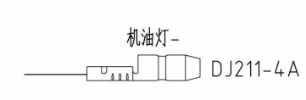 |  |  | Motor oil
 | 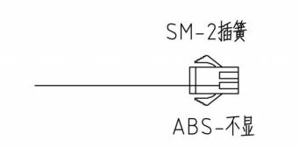 |  |  | Background control buttons
 | 1 2 3  端子 DJ621-E2.8*05  塑料件 DJ7031A-2.8-21 |  |  | - Red / White: Sensor positive  - Green / Blue: sensor negative  - Black / White: sensor signal

Background parameter setting
Press and hold the button, ACC power on, enter the background password interface, short press plus 1, long press to shift, enter the correct password 6810, the following interface is displayed. Press briefly to cycle through the items, and press and hold to modify the displayed value. ACC power down restart takes effect.
project description | Project display | Display value (default) | range
Tire circumference setting | Tire circumference setting | 2000 | 500~2500mm
Sensing | Sensing | 4 | 1~50
Enigne speed signal setting | Enigne speed signal setting | 2 | 2、4
Mileage setting | Mileage setting | The current value | 000000~9999999
Unit setting | Unit setting | KM | KM、MPH
Fuel sensor setting | Fuel sensor setting | 2 | 2、3
Water temperature setting | Water temperature setting | 16 | 1~255Ω
Service | Service | 1000 | 500~5000KM  Stepping500
Softwari version | Softwari version | MCU+ARM

